FRENCH STYLE COURSE SHEEP HERDING TRIAL.

October 4 & 5 2015

BEL CANTO RANCH, Lancaster, CA

Course Instructions and diagrams

STARTED:
1.start at pen. Handler & dog enter pen. Dog should jump into pen. Do protection/inspection of stock with dog. Open gate and exit pen with flock. Dog should hold flock on road while gate is shut.
2. Go down road to bridge. Handler and dog may fetch thru bridge.
3. Continue on fetch/drive thru weave poles then enter B course field.
4. Fetch thru panel 1, go behind freestanding pen and fetch thru panel 2.
5. pause flock and graze (may use shed ring). Catch & hold a sheep while dog contains flock.
6 Gather flock and return via road to repen.

Started Course
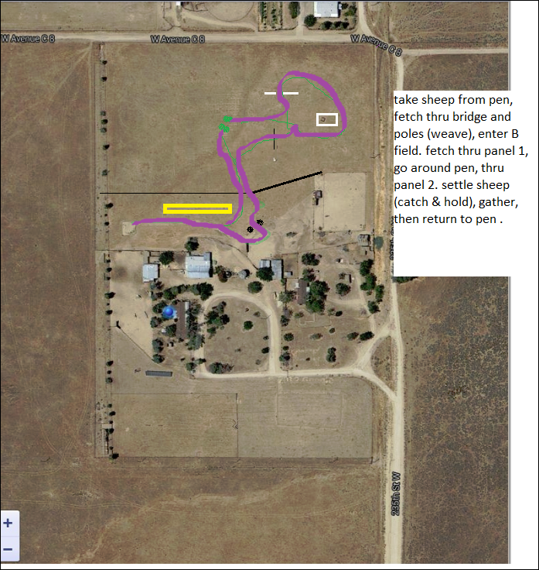

INTERMEDIATE:
1.start at pen. Handler & dog enter pen. Dog should jump into pen. Do protection/inspection of stock with dog. Open gate and exit pen with flock. Dog should hold flock on road while gate is shut.
2. Go down road to bridge. DRIVE thru bridge.
3. Continue down road to water tank. Stop flock.
4. Take flock around circular drive and stop at entrance to field on right.
5. Enter field and take flock to graze area. Catch & hold a sheep while dog contains flock.
6. graze (dog should manage flock so that they don’t exit graze area, are calm enough to lie down or graze).
7. Leave flock and go to handler’s post 150’ away. Dog gathers flock.
8. Return via circular drive past water tank and gates, turn right and drive weave poles.
9. Enter B field and proceed to B course panel 1 and drive panel.
10. Circle freestanding pen (around back) and Return via narrow graze and repen.

Intermediate course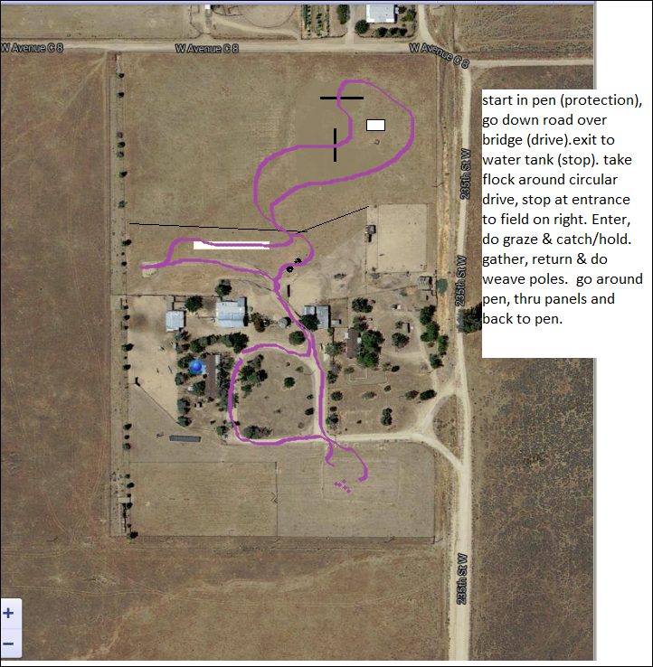

ADVANCED:
1.start at pen. Handler & dog enter pen. Dog should jump into pen. Do protection/inspection of stock with dog. Open gate and exit pen with flock. Dog should hold flock on road while gate is shut.
2. Go down road to bridge. DRIVE thru bridge.
3. Continue down road to water tank. Stop flock.
4. Take flock around circular drive and stop at exit from property.
5. Open gate, collect flock and proceed down road to triangular area of brush. Catch & hold a sheep while dog contains flock in triangular area.
6. exit triangular area and drive flock thru tree lane.
7. stop flock, then cross road to graze area.
8. graze (dog should manage flock so that they don’t exit graze area, are calm enough to lie down or graze). Work at a distance – dog is left in charge of the flock while handler goes at least 100’ to greet judge.
9. Leave flock and go to handler’s post 350’ away. Dog gathers flock.
10. Return via road into yard, turn right. CAR PASS.
11. Continue down road past water tank and gates, turn right and drive weave poles.
12 Enter B field and proceed to B course panel 1 and drive panel.
13. proceed to freestanding pen (around back) and put in 10 head in pen. Signal judge to do head count of sheep.
14. Take remainder of flock and drive second drive panel , then return to pen and collect the 10 head.
15. Stop flock at shed ring.
16. Return via narrow graze and repen.
Advanced Course